IMAGE AND VIDEO PROCESSING
2. Image Enhancement in Spatial domain
2.1 Introduction to Image Enhancement: Gray Level Transformations, Zero Memory Point Operations.
2.2 Histogram Processing.
2.3 Neighbourhood Processing, Spatial Filtering, Smoothing and Sharpening Filters
PAST QUESTIONS:
- State the basic steps in frequency domain filtering.
- Explain the working of the following sharpening spatial domain filters. • The Laplacian • Unsharp masking • High boost filtering.
- Perform Histogram Equalization for the following image. Show the original and equalized histogram.
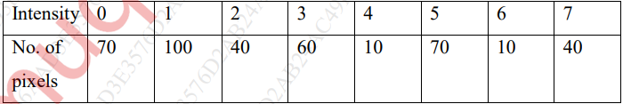
- Justify or Contradict: Every image has a unique histogram. (M24)
- List and explain any four Zero Memory Operations with a diagram representation and equation. Also explain why are they called as Zero Memory Operations. (M24)
- What do you mean by point operations? Explain any three points operations in detail. (D24)
- Explain Histogram Equalization. Equalize the following histogram. Plot the Input histogram, transformation function and output histogram for 3bpp image given below:
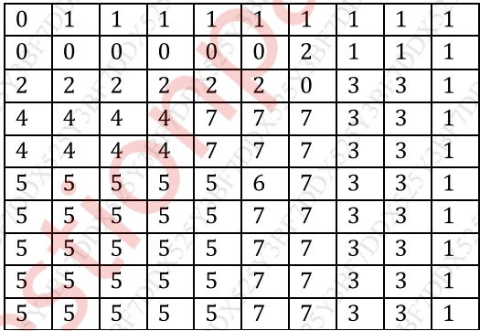
- Explain in detail Sharpening filters. (D24)
- Neighbourhood processing. (D24)
NOTES:

*Frequency Domain Filtering :-
Frequency domain filtering involves modifying the Fourier transform of an image to enhance or suppress certain frequency components (like noise, edges, etc.).
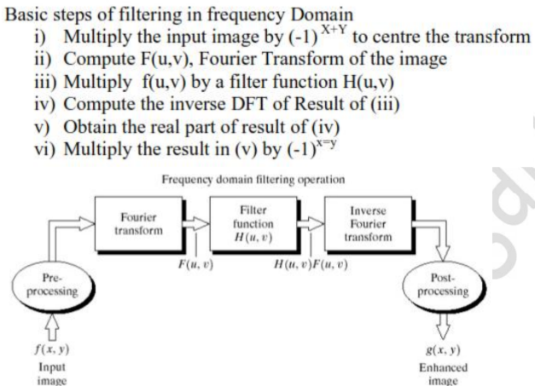

*Zero Memory Point Operations :-
In image processing, "zero-memory point operations" (also known simply as point operations) refer to pixel-wise operations that affect each pixel independently of all other pixels — i.e., the output value of a pixel depends only on the value of that pixel in the input image and not on any neighbouring pixels or previous outputs.
These operations enhance an image by manipulating each pixel value independently of its neighbours. That is, the output at any pixel depends only on the input value at that pixel — hence "zero memory".
Zero Memory means the operation does not require information from any neighbouring pixels.
Various Zero memory point operations:
- Contrast Stretching Transformation – Enhances the contrast of an image by stretching the range of intensity values. It maps input intensity levels to a wider output range.
Improves visibility in images with low contrast.
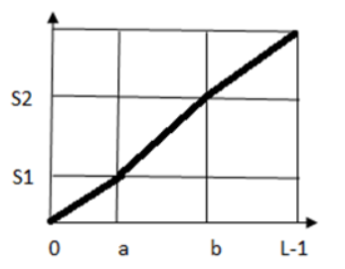
- Thresholding – Converts a grayscale image into a binary image based on a threshold value.
Used in image segmentation to isolate objects from the background.
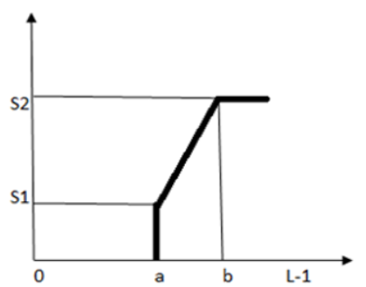
- Bit Level Slicing Transformation – Analyzes the contribution made by individual bits to the overall appearance of an image.
Bit slicing isolates specific bit planes.
Used in data hiding/steganography.
- Digital Negative Transformation – Creates the negative of an image by inverting its intensity values.
Useful for enhancing white/bright features in a dark background — often used in medical or satellite images.
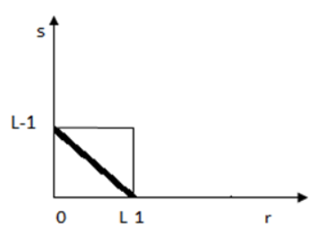

*Histogram Equalization :-
Suppose we have an image which is predominantly dark. Then its histogram would be skewed
towards the lower end of the grey scale and all the image detail are compressed into the dark
end of the histogram.
Histogram Equalization is an image enhancement technique that improves the contrast of an image by redistributing the intensity values so that they span the entire range more uniformly.
Histogram equalization is a common technique for enhancing the appearance of images.
It is used to enhance images with poor contrast, often caused by low lighting or limited dynamic range.
Histogram equalization results a new image that has a flattened histogram, more spread-out intensities, improved contrast.
Applications –
- Medical imaging (X-rays, MRI)
- Satellite imagery
- Industrial inspection

*Sharpening Filters :-
Sharpening is an image enhancement technique used to highlight edges, fine details, and transitions in intensity. It works by emphasizing the high-frequency components of the image, which correspond to rapid changes like edges and noise.
Need of sharpening:
- To enhance edges and boundaries of objects.
- To improve image definition and visibility.
- To help in feature extraction, object detection, and image analysis.
Types:
- Laplacian Filter – Computes the second derivative of the image to detect regions with rapid intensity change. It enhances edges in all directions.
Working:
- Apply Laplacian operator to image to get the edges.
- Subtract this from the original image to get the sharpened result.
- Unsharp Masking – Enhances edges by subtracting a blurred version of the image and adding it back to the original.
Working:
- Blur the image using Gaussian or box filter.
- Subtract the blurred image from the original to get the mask.
- Add the mask to the original image.
- High-Boost Filtering – A generalized form of unsharp masking that allows adjustable sharpening using a boosting factor (A).
Useful when original image details need to be retained along with enhanced features.

*Neighbourhood Processing :-
Neighbourhood Processing refers to the technique where the new value of a pixel in an image is determined by applying an operation on the pixel’s local neighbourhood — a small window of pixels surrounding the target pixel.
Key points –
- The neighbourhood is usually a square window (e.g., 3×3, 5×5 pixels) centred on the pixel of interest.
- The operation considers the intensity values of the pixels within this window.
- Common operations include smoothing, sharpening, edge detection, noise removal, and filtering.
Example of Neighbourhood Operations –
- Smoothing filters: Mean filter, Gaussian filter (reduce noise)
- Edge detection: Sobel, Prewitt, Laplacian (highlight edges)
- Sharpening: Unsharp masking, High boost filtering
- Median filter: Replace pixel by median of neighbourhood (good for salt-and-pepper noise)

*Smoothing Filter :-
A smoothing filter is used in image processing to reduce noise and details by averaging pixel values with their neighbours. It helps to blur the image slightly, making it smoother and less noisy.

Low Pass Filter –
A Low Pass Filter allows low-frequency components of an image to pass through and reduces the high-frequency components.
In images, low frequencies correspond to smooth areas or slow changes in intensity.
High frequencies correspond to edges, noise, or abrupt changes.
Purpose of Low Pass Filters
- To smooth an image by reducing noise and fine details.
- Removes sharp edges and sudden intensity changes.
- Used as smoothing filters.
Examples of Low Pass Filters
- Mean filter (average filter)
- Gaussian filter
How They Work
- They average neighbouring pixel intensities to reduce intensity variation.
- Result: image looks blurrier, noise reduced, edges softened.

High Pass Filter –
A High Pass Filter allows high-frequency components (edges, fine details) to pass through and reduces the low-frequency components (smooth areas).
This highlights rapid intensity changes like edges or texture.
Purpose of High Pass Filters
- To detect edges or sharpen the image.
- Emphasizes fine details and boundaries.
Examples of High Pass Filters
- Laplacian filter
- Sobel filter
- Prewitt filter
How They Work
- They compute differences between a pixel and its neighbours to detect sudden changes.
- Result: image highlighting edges and textures.

